CloudFlare Live Tunnel URL Setup and Config:

https://docs.google.com/spreadsheets/d/1Ik156fVdDTnRgXTZo9XWIL1_jqEIiKDBuP1-yF6kU64/edit?gid=0#gid=0

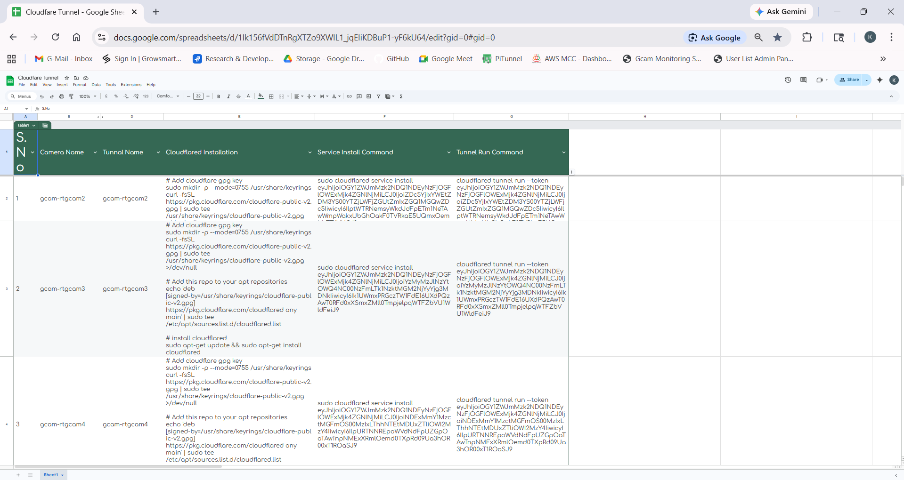
For Example : rtgcam12
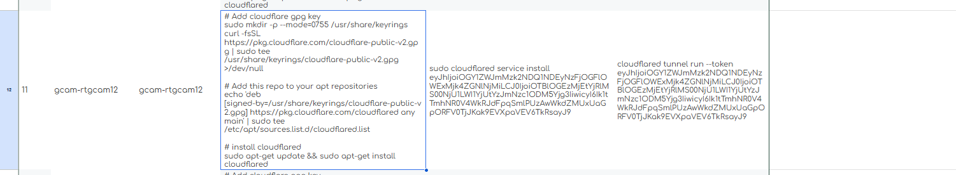
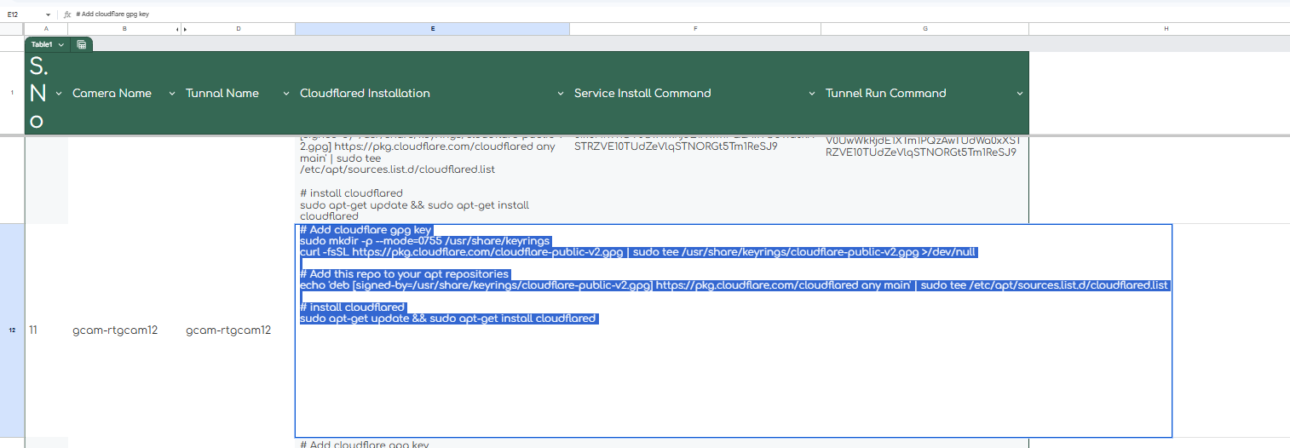
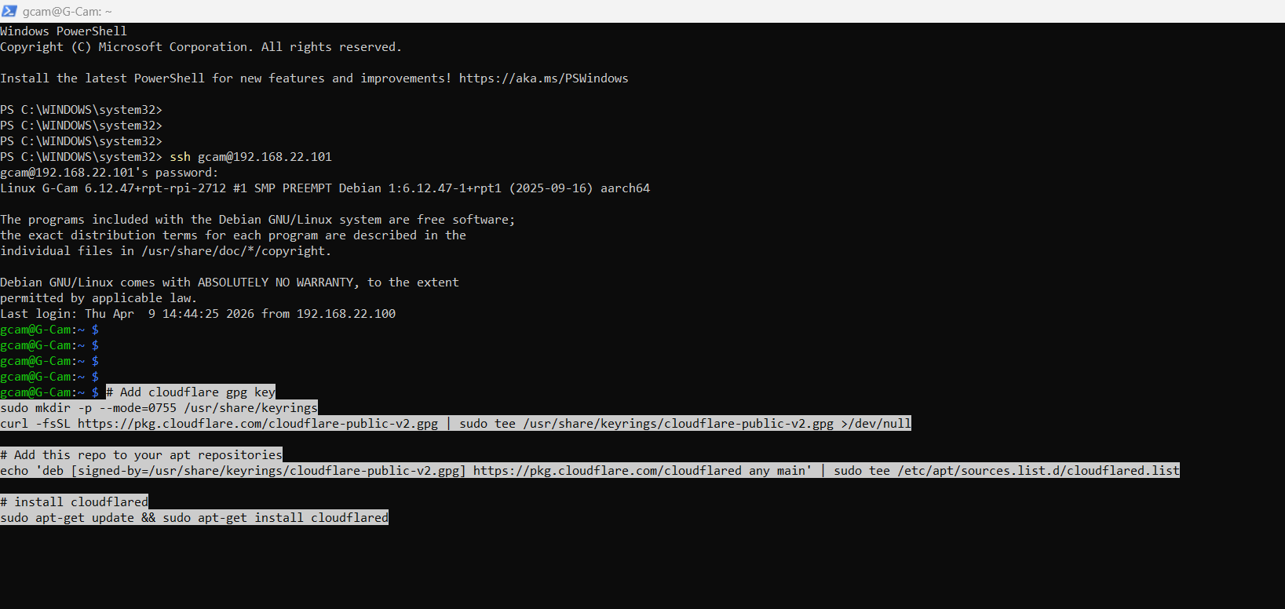
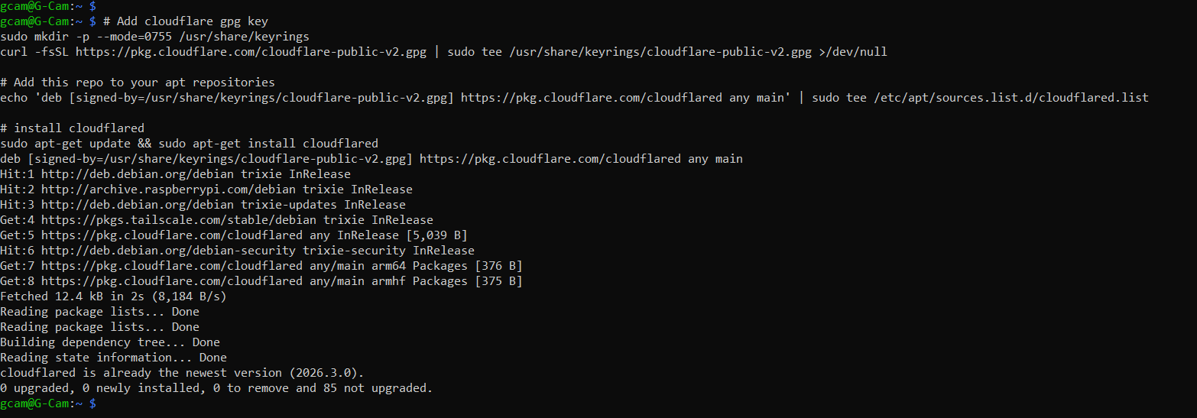
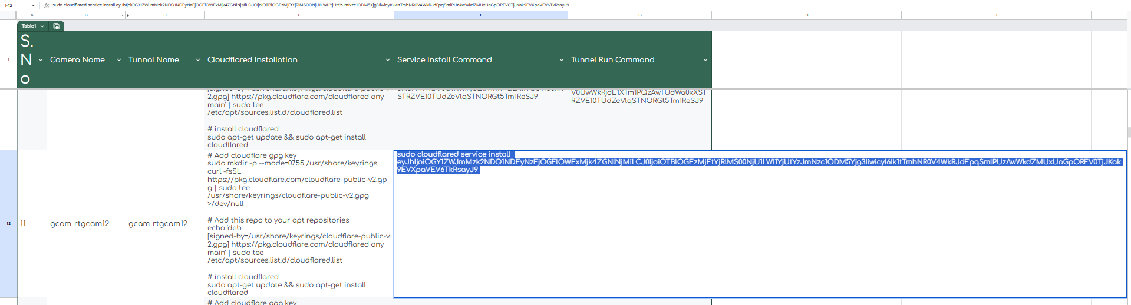
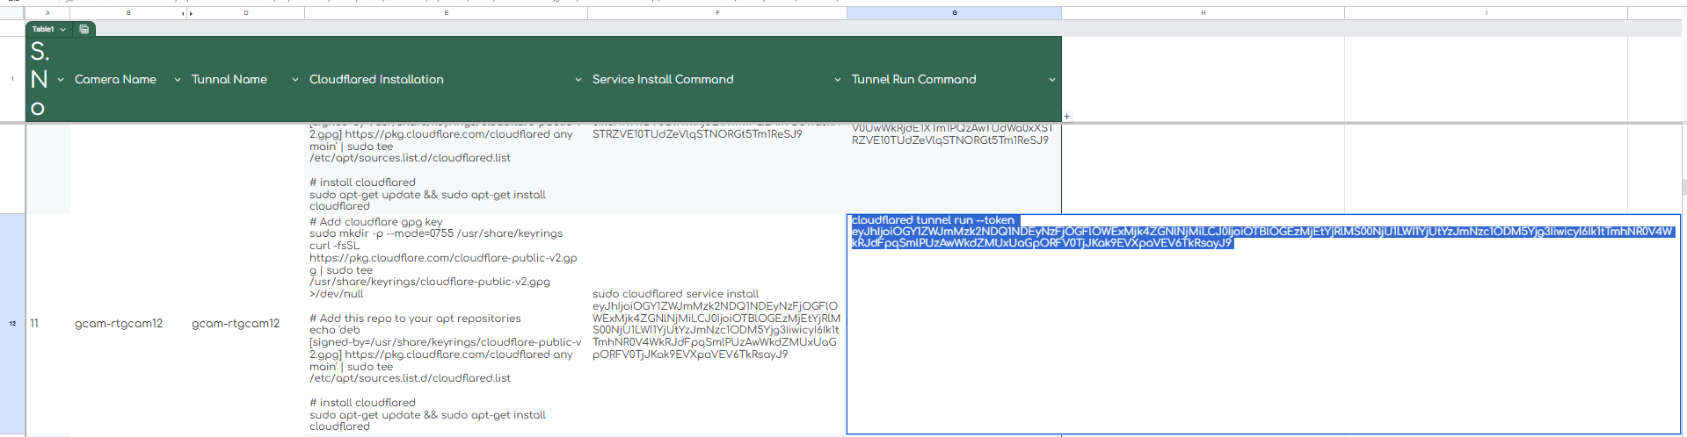
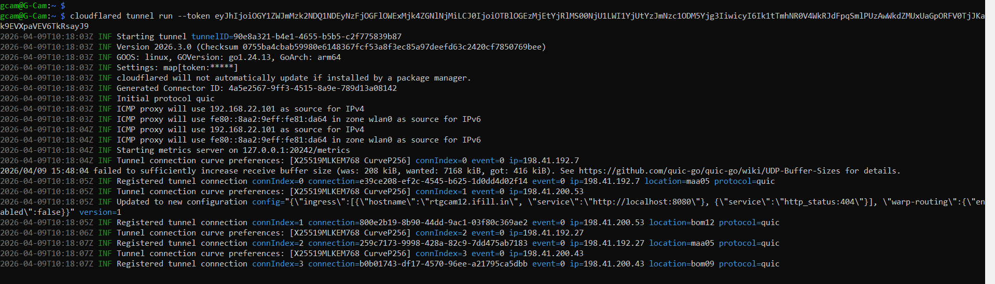
Cntl + C
Cntl + C
Enter

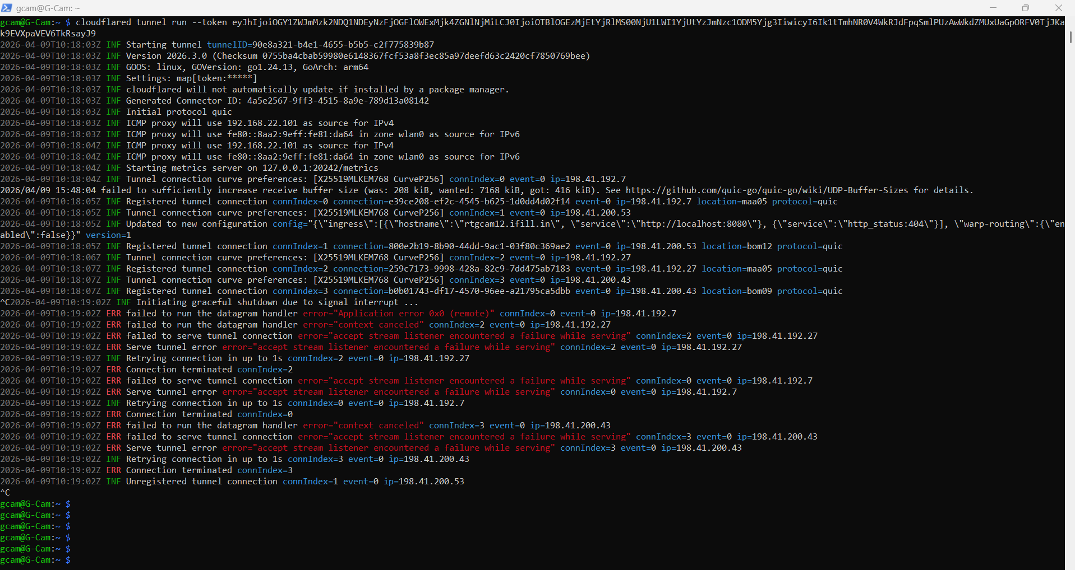
echo "nameserver 1.1.1.1
nameserver 8.8.8.8" | sudo tee /etc/resolv.conf

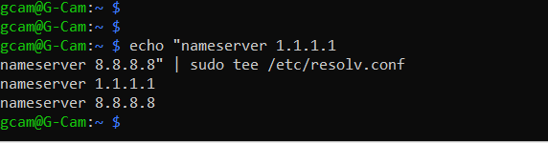

ping -c 2 region1.v2.argotunnel.com
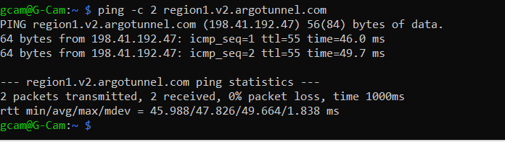

sudo systemctl enable cloudflared
sudo systemctl restart cloudflared
journalctl -u cloudflared -n 100 --no-pager

